**Personal Learning Plan**

Delivery Date: 5th of December – 2016

Subject: Web Design

Strengths: Enjoy coding

Weaknesses: Lack of free time

1. **SPECIFIC:**

Deliver a Web Site by 5th of December, this website will talk about kites a new product to be introduce in the irish market. It will have 4 pages

1. **First Page:** It’s the home page, where there will be some information about the product, leading the user to the second page.
2. **Second Page:** Its about images so the user can have a better idea of our final product and visualise better what is the WebSite about.
3. **Third Page:** That’s where the user can contact us, with an order, with a special customisation, with queries or any sort of information, complains, advices etc. There is a big text box where the user will be able to use for talking to us.
4. **Buy Now :** Where the user can buy our products in bundles or individually, he will be able to visualise and check the prices described below the images available.
5. **MEASURABLE:**

Those four pages can be built in about 20 hours of work, based on exercises done before. It is required 4 pages using HTML, CSS and JavaScript. Must have at least 1 external CSS file and 3 JavaScript functions. All resources has been given.

1. **ACHIEVABLE:**

The general goal of the website is to introduce slowly the new product into the market, the initial goal is to have at least 5 people a month at least looking at the website and at least 1 deal closed, either by bundle or single sale.

1. **RELEVANT:**

This will help me to set a business of my own, doing something I like it and benefit financially out of it. Also will give me experience for new business or idea in the future.

1. **TIME-BOUND:**

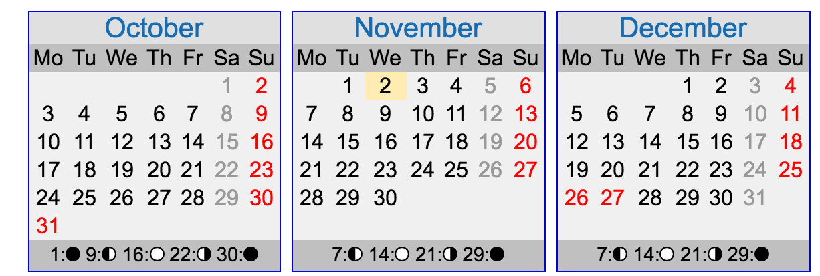

Today as highlighted is the 2nd of November and the website developing is already happening. The deadline is in 5 weeks, the overall hours calculated for finishing the entire project is about 20 hours of work, I have added extra 5 hours for any unexpected addition or fact that may happen in the course of developing. So the total hours of work estimated is 25 hours, using 4 hours every Sunday for working on it should be plenty, considering that I have done about 5 hours of work already, but just to make sure that I won’t be putting myself under pressure, I am adding 2 hours of work every Wednesday. So before the deadline is due I should have 2 Sundays spare for testing, checking for bugs, and if the website meet the requirement list before deploying it live.